

ABC Awards Level 2
Motor Vehicle Studies

Underpinning Knowledge Evidence Record

M/601/6028 Knowledge of Inspecting Vehicles using Prescribed Methods

Learners Name
ABC Awards Registration Number
Centre Name
Assessor 1 Name
Assessor 2 Name

DECLARATION OF AUTHENTICITY

This declaration must be completed and signed by the learner and countersigned by the tutor / assessor and covers all evidence submitted for moderation.

Learner Name
Unique Learner Number (ULN) |  | ABC  Learner Reg. ID
Qualification Title
Centre Name

Learner statement of authenticity

Before signing please read the guidance below.

I confirm, that the attached assignment / portfolio is all my own work and does not include any work completed by anyone other than myself. I have completed the assignment / portfolio in accordance with ABC Awards’ instructions and within the time limits set by my centre.

Signature |  | Date

Centre confirmation of authenticity

On behalf of …………………………………….(insert centre name), I confirm that the above mentioned learner, to the best of my knowledge, is the sole author of the completed assignment / portfolio attached, and the assessments have been completed under the required conditions.

Signed |  | Date
Name
Title

Guidance for Learners

You have been asked to sign this Declaration of Authenticity and place it at the front of your portfolio or course work assessment. It confirms that the work you have submitted for assessment is your own and that you have not copied it from someone else or allowed another learner to copy it from you.

When preparing any course work it is good practice to undertake research using information from published sources. If you quote directly from these sources then this must be indicated in your work by using quotation marks and referencing the document from which the quotation was taken. You must then comment in your own words on any ideas expressed.

Assessors, internal verifiers and ABC Awards’ external moderators and verifiers are subject specialists who can spot the use of published materials that may be passed as your own words or ideas.
If you do copy words from a published source and do not indicate their reference you will be committing plagiarism. This is considered a form of cheating and may result in your assessment being declared void

Contents

Task No | Title | Assessment Criteria
1 | Inspections on light vehicles | 1.1, 1.3, 1.6, 1.7, 1.10
2 | Methods of inspection | 1.2, 1.3, 1.4, 1.5, 1.6, 1.7
3 | Workshop responsibilities | 1.8, 1.9

Task 1 – Inspections on light vehicles | Assessment Criteria 1.1, 1.3, 1.6, 1.7, 1.10

Why is it important to complete the inspection sheet fully and in a logical sequence?
Use the diagram below to identify any pre-existing damage and state how you would report this
Vehicle Details |  | Vehicle Body Report
Make_____________________________  Model____________________________  Registration/VIN No._________________  Colour____________________________ |  | 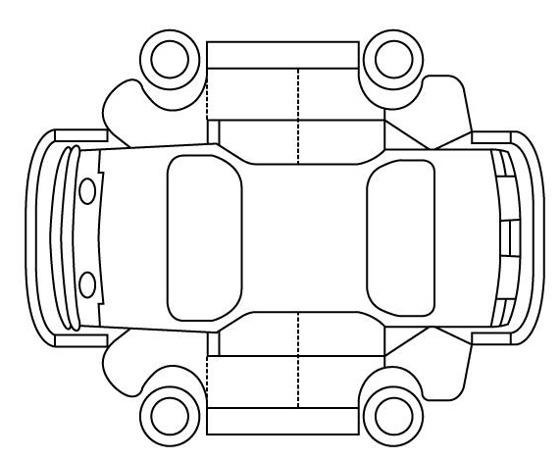
Identify the different systems to be inspected during vehicle inspection |  |  | Sources of Information Used
 |  |  | Work  shop  Manual   | Autodata   | Internet   | Other  (State)
1.
2.
3.
4.
5.
6.
7.
8.
Explain when you would you carry out the following types of inspection
Pre-work
Installed system check
Pre-delivery
Vehicle handover inspection

Task 2 – Methods of inspection | Assessment Criteria 1.2, 1.3, 1.4, 1.5, 1.6, 1.7

Identify and describe the inspection methods you used to ensure a vehicle conforms to the manufacturers’ specifications

Engine
Component |  | Method of inspection | Compare findings against vehicle specification / legal requirements
1.
2.
3.
4.
5.
Chassis (steering, suspension, brakes, wheels and tyres)
Component | Method of inspection |  | Compare findings against vehicle specification / legal requirements
1.
2.
3.
4.
5.
6.
7.
8.
Transmission and driveline
Component | Method of inspection |  | Compare findings against vehicle specification / legal requirements
1.
2.
3.
4.
Electrical and electronic
Component | Method of inspection |  | Compare findings against vehicle specification / legal requirements
1.
2.
3.
4.
5.
6.
7.
8.
9.
10.

Vehicle interior and exterior
Component | Method of inspection | Compare findings against vehicle specification / legal requirements
1.
2.
3.
4.
5.
6.
7.
8.
9.
10.

Task 3 – Workshop responsibilities | Assessment Criteria 1.8, 1.9

Explain the implications of failing to carry out light vehicle inspection activities correctly
Why is it important to sign and date workplace documentation and vehicle records?

Unless otherwise stated e.g. for some entry level qualifications, learners can work together but should identify sections which are their own work.

